Project Design Phase-II

Data Flow Diagram

|  |  |
| --- | --- |
| Date | 23-10-2022 |
| Team ID | PNT2022TMID34081 |
| Project Name | Deep Learning Fundus Image Analysis for Early Detection of Diabetic Retinopathy |
| Maximum Marks | 4 Mark |

FLOW DIAGRAM:

Simplified Diagram :

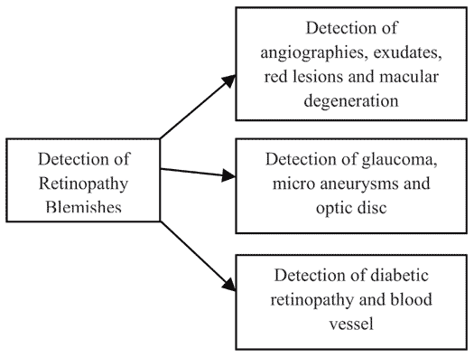

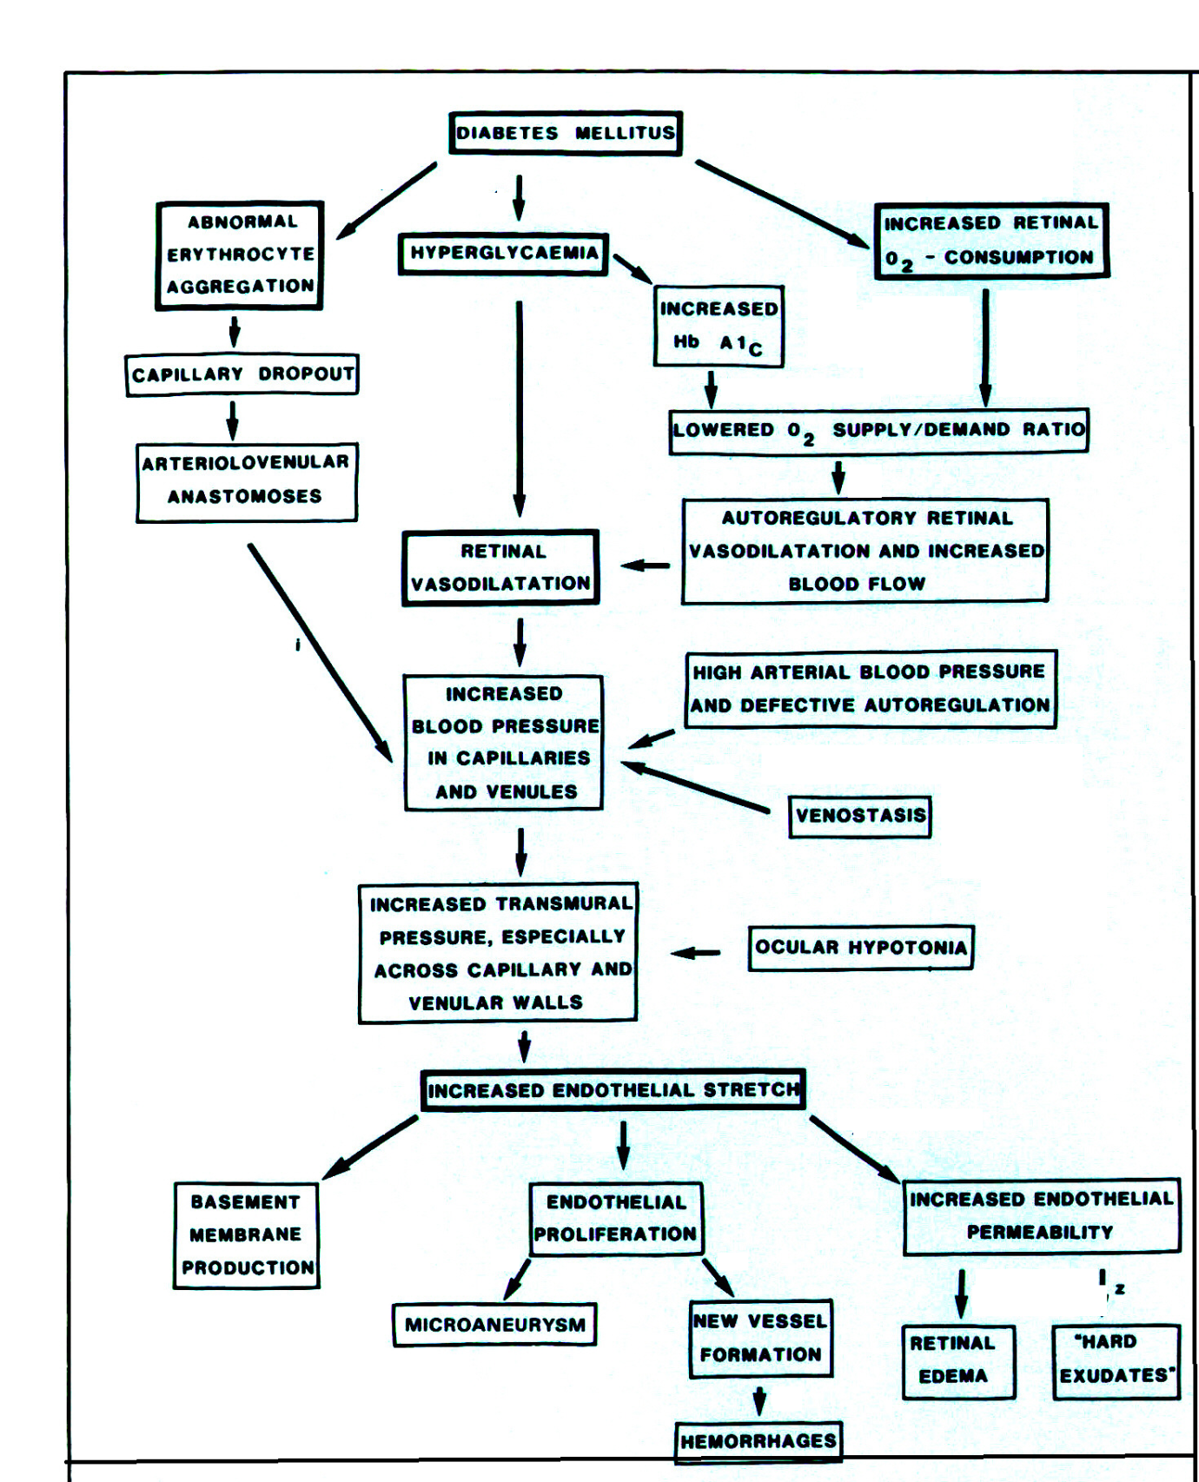

|  |  |  |  |
| --- | --- | --- | --- |
| User Type | Functional Requirements | Acceptance | Abstaining |
| UT1 | Self care | Eating a diabetic diet that decreases fluctuations in blood sugar levels and proper exercise | If untreated with uncontrolled diabetes, the condition may lead to,Vitreous haemorrhage,Retinal detachment |
| UT2 | **Medication** | To prevent growth of abnormal blood vessels. Especially when central vision is getting affected. | Without proper medication it will should seek increase in dosage of hypoglycemia |
| UT3 | Health information and data | Healthy lifestyle choices not only reduce your risk of developing diabetic retinopathy, they can also have a significant impact on your management of the condition. | * Difficulty seeing at night * Limited peripheral vision * Sudden loss of vision. |
| UT4 | Treatment | laser treatment, also known as focal laser treatment, can stop or slow the leakage of blood and fluid in the eye. During the procedure, leaks from abnormal blood vessels are treated with laser burns. | **Without treatment**, scars can form in the back of the eye. Blood vessels may also start to bleed again, or the bleeding may get worse. |